Julia Bullock, vocalist
At a glance

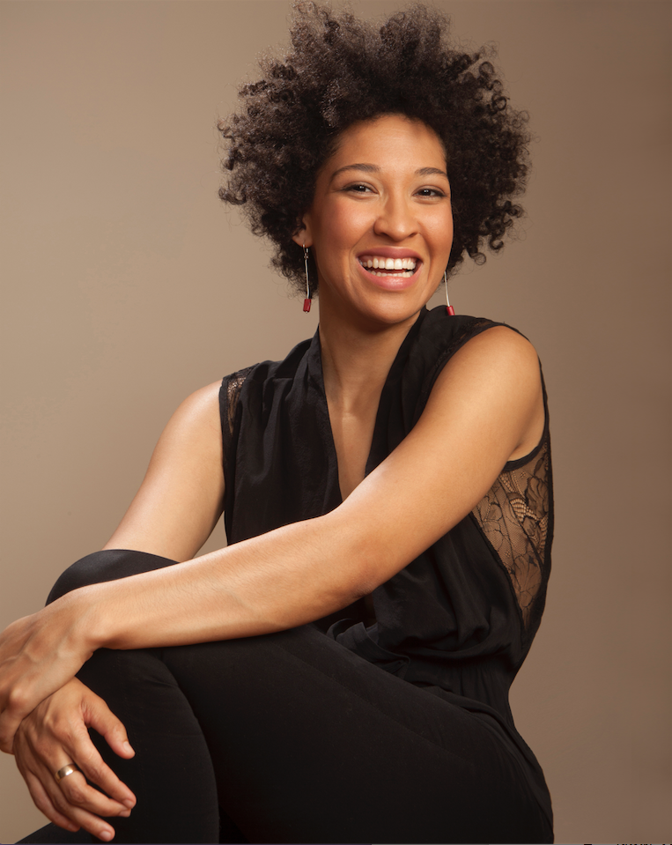
American vocalist Julia Bullock is “a musician who delights in making her own rules” (New Yorker). Combining versatile artistry with a probing intellect and commanding stage presence, she has, in her early 30s, already headlined productions and concerts at some of the preeminent arts institutions worldwide. An innovative programmer whose artistic curation is in high demand, she was recently named 2019-20 Artist-in-Residence of San Francisco Symphony, while her other curatorial positions include 2018-19 Artist-in-Residence of New York’s Metropolitan Museum of Art, opera-programming host of new broadcast channel All Arts, and founding core member of the American Modern Opera Company (AMOC). Chosen as one of WQXR’s “19 for 19” artists to watch this year, Bullock is also a prominent voice of social consciousness and activism. As Vanity Fair notes, she is “young, highly successful, [and] politically engaged,” with the “ability to inject each note she sings with a sense of grace and urgency, lending her performances the feel of being both of the moment and incredibly timeless.”

Spring 2019 highlights:
- Continues season-long residency at NYC’s Met Museum of Art
- Reimagines role of Josephine Baker in Perle Noire: Meditation for Joséphine at Met Museum (Jan) and at OBERON in Cambridge, MA (May)
- Feb-March: Reprises role of Dame Shirley in John Adams’s Girls of the Golden West at Dutch National Opera
- April: Premiere of “Zauberland: An Encounter with Schumann’s Dichterliebe” recital: iconic song cycle plus 16 new songs by composer Bernard Foccroulle & writer Martin Crimp, in Théâtre des Bouffes du Nord (Paris)
- May: Curates final concert of residency at Met Museum, with American Modern Opera Company (AMOC)
- June: Stars in world premiere of Terence Blanchard’s Fire Shut Up in My Bones at Opera Theatre of St. Louis

Media links:
- NYC-Arts profile focusing on curating “History’s Persistent Voice” program, part of Met Museum residency
- Vanity Fair profile focusing on Met Museum residency
- Limelight magazine profile: Julia Bullock: Force of Nature and Force of Nurture
- Artist Portrait before her 2018 Weill Hall recital at Carnegie Hall
- New Yorker review: The Artistry of the Soprano Julia Bullock
- Pacific Standard: Bullock is Fighting for Social Justice One Song at a Time
- New York Times video: In Performance with Julia Bullock
- High-resolution photos can be downloaded here.
Interesting facts:
- Raised on & influenced by a mixed diet of musical genres — from mother’s ‘60s & ‘70s rock, folk, & psychedelic music to father’s blues & jazz; Nina Simone & Billie Holiday were early musical influences
- Has danced since age 5 (rhythm tap, modern, hoofing) and performed in musical theater shows until college
- Has integrated social activism into her musical career. Works with non-profits such as Turn the Spotlight, Shropshire Music Foundation and Common Fire Foundation
- Her activist side comes from her father. He once shared a jail cell with Dr. Martin Luther King Jr. following a protest and sit-in.
- Does impressions of female icons such as Ethel Merman, Édith Piaf, and certain Disney princesses

Awards & media recognition:
- 2019: Named one of WQXR’s “19 for 19” artists to watch in 2019
- 2018: Grammy nomination for Dr. Atomic with Adams & BBC SO (Best Opera); made “2018 Best Classical Music” lists of New York Times, LA Times, Washington Post, Philadelphia Inquirer; New York Times’s “25 Best Musical Tracks of 2018”; Opera News’s “18 to Watch in 2018-19”
- 2016: Sphinx Medal of Excellence; on New York Times “Best Classical Music of 2016” list
- 2015: Leonore Annenberg Art Fellowship, Richard F. Gold Grant from Shoshana Foundation, Lincoln Center Martin E. Segal Award
- 2014: First place at Naumburg International Vocal Competition
- 2013: Grammy nomination for West Side Story at SF Symphony (Best Musical Theater)
- 2012: First Place at Young Concert Artists International Auditions
Recording highlights:
- 2018: BBC Symphony Orchestra’s Doctor Atomic (Kitty Oppenheimer, Nonesuch); nominated for Grammy
- 2017: Ravel, Dutilleux, Delage, LSO/Simon Rattle (Quatre poèmes hindous; DVD, LSO Live)
- 2015: The Indian Queen (Sony Classical)
- 2014: San Francisco Symphony’s West Side Story – live concert recording (A Girl, SFS Media); nominated for Grammy

What the critics are saying:
- "Bullock’s voice and vision are forces to be reckoned with."— Opera News
- "Julia Bullock, one of opera’s fastest-rising stars, is using her artistic platform for social activism to glorious effect ... She’s young, highly successful, politically engaged—but not least is her ability to inject each note she sings with a sense of grace and urgency, lending her performances the feel of being both of the moment and incredibly timeless." — Vanity Fair
- “Bullock's radiant soprano shines brightly and unfailingly… Most compellingly, however, she communicates intense, authentic feeling, as if she were singing right from her soul.” — Opera News
- "The St. Louis native is a recitalist of rare talent and integrity. With nothing routine or expected about her, the soprano is very much her own law." — Opera News
- “The strongest singing of the evening belongs to Julia Bullock, who filled the summer air with magic with a show stopping rendition of the song “Somewhere.”” — Variety
- “She rendered the gorgeous yet not oversweet melodies beautifully, but there was much more than mere vocal allure: superb diction and a compelling stage manner that would have communicated much of the meaning even if the words had not registered so clearly.” — New York Times
- “Just as remarkable was the firecracker energy of rising-star soprano Julia Bullock, making her BSO debut.” — Boston Globe
- “Julia Bullock, who sang “Somewhere” … stopped the show in every way. She added a spiritual dimension that demonstrated that a social tragedy requires spiritual inquiry.” — Los Angeles Times
- “She was, in a word, spectacular. Her affinity for the Schubert was remarkable, tossing off the songs as if she were a native speaker of German and commenting on the music as she went along.” — Broadway World

Career highlights:
- 2019: Named opera programming host of All Arts; Artist in Residence of SFO’s 19-20 season
- 2018: Artist in Residence at Met Museum throughout 2018-19 season, curating programs including ”History’s Persistent Voice” and “Perle Noir”; North American recital tour including Cal Performances (UC Berkeley), Carnegie Hall (NYC), Celebrity Series (Boston), Philadelphia Chamber Music Society; gave master classes and school performances in each city
- 2017: Founding member of American Modern Opera Company (AMOC); Dame Shirley in SF Opera’s world premiere of John Adams’s Girls of the Golden West; Pamina in The Magic Flute and Hollywood Bowl debut with LA Phil/Dudamel; Anne Trulove in The Rake’s Progress at Aix En Provence; launched Boston SO’s season in Bernstein Gala; recital debut at Disney Hall (LA)
- 2016: Series of Josephine Baker songs at Ojai Music and Mostly Mozart festivals; sang with LSO/Simon Rattle, Boston SO/Andris Nelsons, LA Phil/Dudamel (West Side Story), & Adams (El Niño)
- 2015: Summer tour with NY Phil/Alan Gilbert to Vail, Santa Barbara, and NYC parks in Bronx & Queens
- 2014: Debut recital tour through NY state, DC, IL, PA, & GA; subsequent tours in 2016
- 2013: Debut with SF Symphony/Tilson Thomas; concert album received Grammy nomination

Biographical info:
- Born in Saint Louis, Missouri
- Joined Opera Theatre of Saint Louis’s artist-in-training program in high school; has maintained long-standing relationship with company and often returns for season and benefit performances
- Degrees from Eastman School of Music (BM), Bard College (MM), and Juilliard School (AD)
- Married conductor Christian Reif in 2018. The couple met at Juilliard in 2014.
- Lives in New York City and San Francisco

For full list of Bullock’s season engagements, see schedule page of her web site.

http://www.juliabullock.com/
https://twitter.com/JuliaBullockSop
https://www.instagram.com/juliabullocksoprano/
https://www.facebook.com/julia.bullock.581

©21C Media Group

